  HOA LAC | COMPUTER FUNDAMENTAL DEPARTMENT
SAMPLE PRACTICAL EXAM
Code Question:
«TT»
Fall 2017
DD/MM/2017

SUBJECT: Programming fundamentals (PRF192)
Duration: 85 minutes
Student Information

Name: |  | Roll number:
Room No: |  | Class:
For STAFF only
mark | marked by  (Name and Signature)
Signature of Proctor

INSTRUCTIONS
Please read the instructions carefully before answering the questions. Do not start until you are told to do so.
- Students are allowed to use any books and materials.
- Students are NOT allowed to use mobile phone, Internet, Intranet, Yahoo Messenger, CMS, USB, and all applications that help share information.
- Students are NOT allowed to transmit information and exchange materials with any other during the examination period.
- Students must follow the following requirements (if not will get ZERO):
- Students have to copy PEAClient_Version4.zip to computer and use it. PEAClient_Version4.zip is located on:
\\FSTU\Khao_Thi\03_Exam_Online
- For each question, create a folder in your computer that has two sub folder RUN and SRC. Copy .exe file into RUN sub folder and all source file (*.cpp) into SRC sub folder.
- For submitting, chose question number in PEA software, and then attack appropriate folder was created. Click Submit button to finish submitting this question.
Question 1: (4 marks, file to be edited: Q1.cpp)
Notes: (1) You can create new function(s) if you see it is necessary. (2) In the main function: (a) Do not edit given statements. (b) Write statements in the indicated area only.

TC1:
Enter data for 3 given variables a, b and c, then sort them in ascending order (see sample output).

TC2:
Enter data for a given integer variable n, then calculate the value s = sum of all prime digits of n. E.g. if n = 1243 then s = 2 + 3 = 5.

Sample input and output:
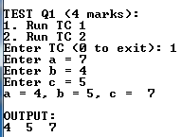 | 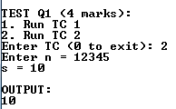

Question 2: (4 marks, file to be edited: Q2.cpp)
Notes: (1) Your task is to complete 2 functions: fen() and fun(). (2) You can create other function(s), if you see it is necessary. (3) Do not edit the main function.
TC1:
Complete the given fen(double x, double y, int n) function, which calculates and returns the value fen(x,y,n) using the formula below:

fen(x,y,n) = (1+ 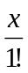 + 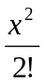 + ... +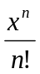) + (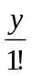- 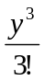 + 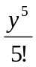 -... +(-1)^{n} 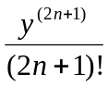)

TC2:
Write statements to complete the function fun(int a[], int n) in the given file Q2.cpp. Suppose the array a contains at least 4 elements. The task of the function fun:
check if n is odd (e.g. n = 5) then sort the array a ascendingly,
otherwise (i.e. n is even) sort the array a descendingly.

Sample input and output:
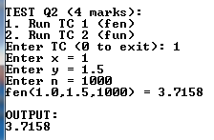 | 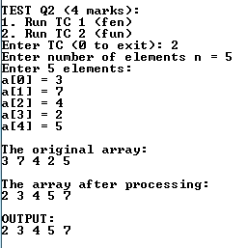 | 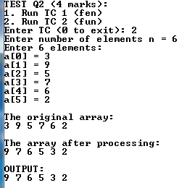

Question 3: (2 marks, file to be edited: Q3.cpp)
Complete the function fun(int tc, char s[]). The task of the function fun
if tc = 1 then
sort all words in the string s ascendingly (other words are unchanged),
otherwise
delete the first and the last word of the string s.
Notes: (1) word is a string without space(s) (2) You can create new function(s) if you see it is necessary. (3) Do not edit the main function.

Sample input and output:

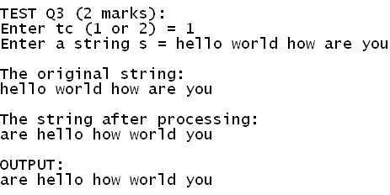 | 